# AMP Installation

<https://www.apachelounge.com/download/>  
Extract the fie land copy it to c:\apache

Edit the file "C:\apache\conf\httpd.conf".

Change all references from Apache24 to apache.

*ServerName localhost:80*

c:\apache\bin>dir *.exe

*httpd* will start the service:

"C:\apache\htdocs\index.html" is the default document root.

**Run Apache as a Windows service**

c:\apache\bin>httpd.exe /?

**httpd -k install**  : install an Apache service

$ httpd -t 🡺 Syntax OK

OR: net start apache2.4

To uninstall apache: httpd -k unnistall

**PHP:**

Extract it to c:\php. Look for php7apache2_4.dll file. This is what apache will look for. In C:\apache\conf\httpd.conf:

*LoadModule php7_module "C:/php/php7apache2_4.dll"  
AddHandler application/x-httpd-php .php  
PHPIniDir "c:/php"*

Rename php.ini-development top hp.ini (in c:\php directory)

Php.ini:

*display_errors = On (very important for development)*

Create in c:\apache\htdocs\phpinfo.php:

<?php

 phpinfo();

?>

Restart apache. Goto <http://localhost/phpinfo.php>

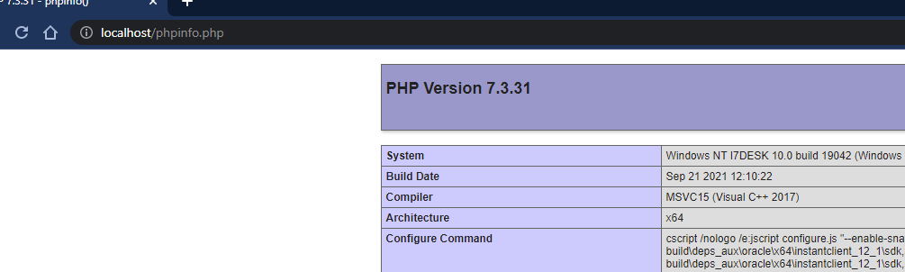

**MySQL**

[**https://downloads.mysql.com/archives/installer/**](https://downloads.mysql.com/archives/installer/)

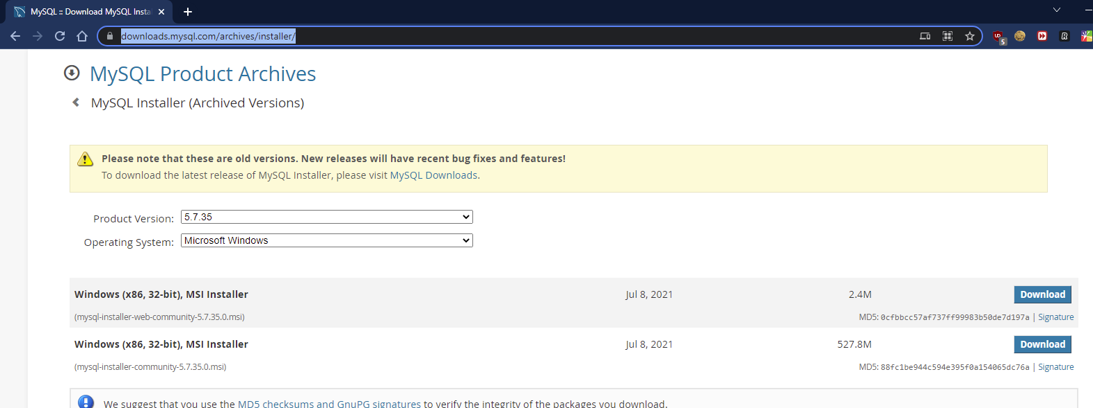

**Custom install:**

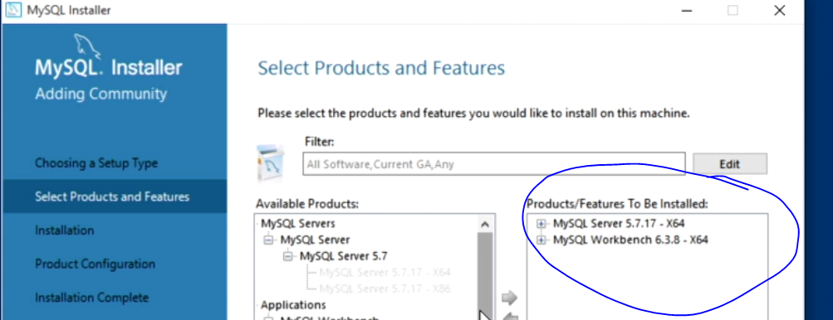

**Add mysql to path:**

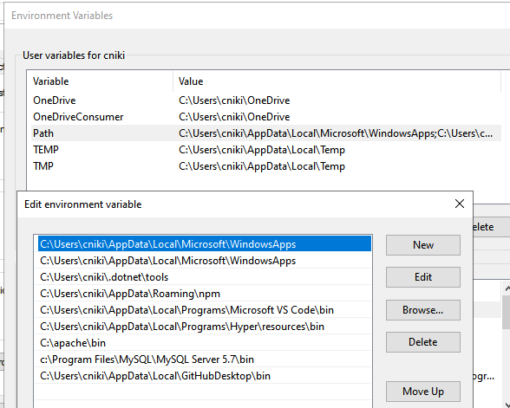

**Test connection:**

*# mysql -u root -p 🡺 root  
show databases;  
use sys;  
show tables;*